**How does CCNA Routing and Switching certification support next-generation Networking Jobs?**

**CCNA (Cisco Certified Network Associate) Routing and Switching certification** is for the network engineers who wants to enhance the knowledge about networking and prove that they are unique in managing networks. CCNA Routing and Switching certification paves path to a bright future for networking professionals. This course lays a strong networking foundation to the aspirants and helps them to install, configure, and operate, smaller to mid-sized networks. To become a CCNA certified professional, enroll in **CCNA Routing and Switching training**.

**Why CCNA Routing and Switching training is important for network professionals?**

**American National Standard Institute (ANSI)**, a member of International Accreditation Forum (**IAF**), has given accreditation to CCNA Routing and Switching certification. Cisco is the first networking company to provide effective network certifications that are accredited by ANSI. CCNA Routing and Switching certification gives a global benchmarking to aspirants and continues to give the certifications that are on par to the industrial standard. This goes without saying that the course provides aspirants with a competitive ground for the next-generation industrial requirements.

**Figure - 1 A simple computer network**

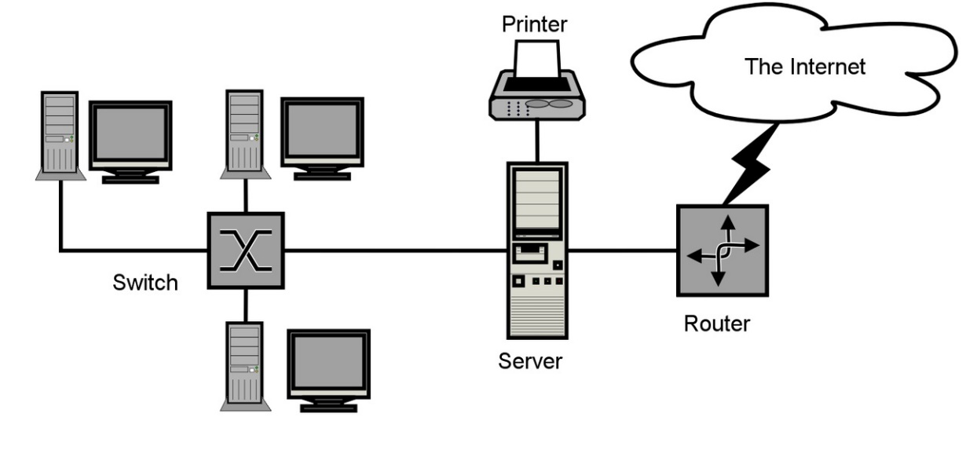

**Source -** <https://en.wikipedia.org/wiki/Computer_network_diagram#/media/File:Sample-network-diagram.png>

**What is covered in CCNA Routing and Switching training?**

The CCNA Routing and Switching course is inculcated in three different sections as follows:

* Course 200-120 CCNA: Cisco Networking Devices: Accelerated (CCNAX)
* Course 100-101 ICND1: Interconnecting Cisco Networking Devices Part 1
* Course 200-101 ICND2: Interconnecting Cisco Networking Devices Part 2

The CCNAX is a section that covers topics for the composite exam, which comes under the CCNA Routing and Switching certification. This covers the topics that are included in ICND1 and ICND2. The candidates can either write a single composite CCNAX exam or write ICND1 and ICND2 separately to become a CCNA Routing and Switching professional.

**Who can join CCNA Routing and Switching course?**

This course is ideal for Network Engineers, Network Specialists, Network Administrators, Systems Engineers who have up to three years of experience. The career growth for a CCNA certified professional is considerably wide in the next-generation networking industry. Enroll in the online [CCNA Routing and Switching training](http://www.multisoftsystems.com/cisco/ccna-training) for better career opportunities.

SMO: **Cisco CCNA Routing and Switching training** program helps networking professional to widen their career opportunity in the advanced networking industry.